Speakers

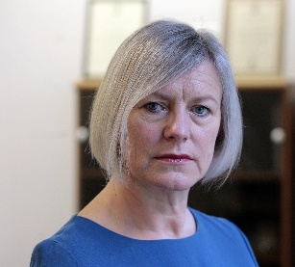
Dame Sara Thornton, DBE QPM, Independent Anti-Slavery Commissioner
Dame Sara Thornton DBE QPM is the Independent Anti-Slavery Commissioner responsible for encouraging good practice in the prevention and detection of modern slavery and the identification of victims. She was Chief Constable of Thames Valley Police from 2007-2015 and the first Chair of the National Police Chiefs’ Council from 2015-2019. She is chair of the National Leadership Centre’s Advisory Board and an Honorary Air Commodore in the Royal Air Force. She is Honorary Professor in Modern Slavery at the Centre for the Study of International Slavery, University of Liverpool.

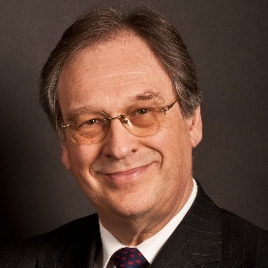
Martin Lawrence MBE BA MEd ACP Cert Ed Director, Wisbech and Fenland Museum
Martin Lawrence has a broad range of experience in the fields of education and business and as a charitable trustee and company director in the education and heritage sectors since the 1980’s.
In the wider charity sector he was a member of the advisory board for The Prince’s Youth Business Trust and a member of the Northamptonshire county board. He is currently trustee/director of Governors for Schools and GLM Partnership, national education charities.
He has been a director of the Wisbech and Fenland Museum since January 2016. He has led the museum development committee and is the responsible director for a number of nationally funded projects, including ‘Articles for Change’.

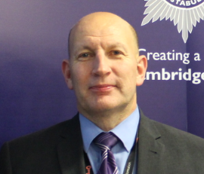
DS Chris Acourt, Exploitation and Modern Slavery team Operation Pheasant
DS Chris Acourt has been a Police Officer in Cambridgeshire for 20 years working in a variety of roles such as CID, neighbourhood policing and specialist team. Chris has been working on the Modern Slavery team for around 6 years based out of Wisbech. Chris regularly gives talks on spotting the signs of Modern Slavery, the journey of a victim, Police responses local area and the challenges around Modern Day Slavery investigation and victim engagement and aftercare.
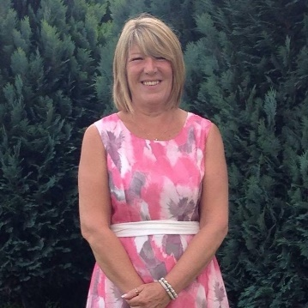
Anita Grodkiewicz, MBE, Rosmini Centre, Wisbech
Anita Grodkiewicz MBE, has a degree in Health & Social Studies and an MA in Marketing & Social Media. She has worked in the Charity Sector for 28 years in a variety of roles. Prior to managing the Rosmini Centre in Wisbech she was with the WRVS. Here she was working with local authority and emergency services, providing emergency rest and reception centres and training statutory and voluntary organisations in the East of England.
Many of the skills gained during her time with the WRVS have been invaluable in the development of the Rosmini Centre. She has been employed in her current role as the Centre Manager for 11 years. During this time the organisation has gone from strength to strength and she has built a team of volunteers, staff and trustees who have been awarded the PQASSO kitemark, Queens Award for Volunteering and Pride in Fenland Award.
She also sits on the Cambridgeshire External Police Scrutiny Committee, The Fenland Community Diversity Forum and is a recently appointed Governor of Thomas Clarkson Academy.
Anita was proud to receive an MBE in the Queens New Year Honours list in 2018 for her work in Wisbech.

Ella Rolfe, Youth Voice and Youth Engagement Partnership Coordinator and the Essential Skills for Life Programme Coordinator for Cambridgeshire County Council.
Ella Rolfe is the Youth Voice and Youth Engagement Coordinator supporting organisations within the County Council to better represent the young people in our area, through young people’s recruitment panels, young commissioner training, young inspectors and being on hand for advice and guidance. Our aim is for young people to have a say in the decisions that impact their everyday lives. In her Essential Skills for Life Programme Coordinator role, Ella and her team support young people through targeted work to improve social mobility within the Fenland Opportunity Area. Through this programme, the team developed and ran a programme of learning within schools that culminazted in residential experiences and are now working with small groups of young people to combat gang behaviour, risk of CCE and involvement with drugs through group work and detached youth work.

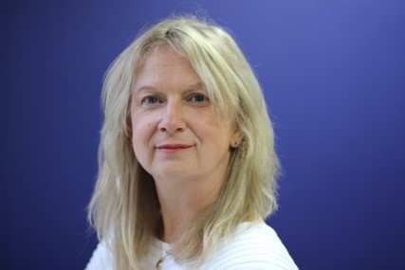
Ruth Dearnley, Chief Executive Officer, STOP THE TRAFFIK
Ruth Dearnley has been Chief Executive Officer of STOP THE TRAFFIK since May 2008. With a law degree and background in education, she inspires and enables people to transform the world around them. STOP THE TRAFFIK is a tech driven, human centred group of organisations that exists to disrupt the global trafficking business economy. Utilising the power of people and technology, STOP THE TRAFFIK's work prevents human trafficking globally through an innovative, intelligence-led approach. Ruth is an energised and passionate leader, dedicated to bringing safety, hope, and choice to communities all over the world. In 2014, Ruth was honoured with the award of an OBE in the British New Year Honours.

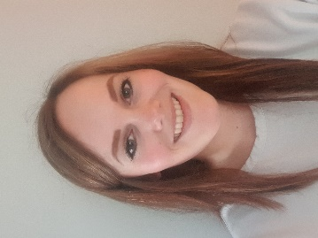
Rachel Dickens, UK Programmes Manager at Stronger Together

Rachel Dickens is a responsible sourcing specialist with 5 years’ experience of international consumer goods supply chains. Rachel manages the Consumer Goods sponsorship programme at Stronger Together, working with UK retailers and businesses to deter, detect and deal with exploitation in their own operations and supply chain. Previous experience includes responsible sourcing strategy implementation and operational human resources. Launched in the UK in 2013, Stronger Together is a multi-stakeholder, business-led initiative aiming to reduce modern slavery, particularly forced labour, labour trafficking and other hidden third party exploitation of workers. Stronger Together provide a range of in-depth, specialist training solutions and free downloadable resources including posters, short films and best-practice toolkits. Stronger Together focus on providing advice, training and resources that are practical, pragmatic and easy for any business, of any size to understand and use.

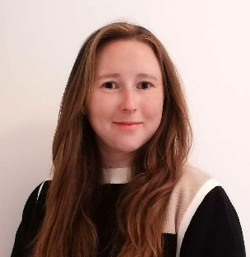
Eliya Lucks, Communications and Fundraising Assistant, Anti-Slavery International
Eliya Lucks is a Communications and Fundraising assistant at Anti-Slavery International. She is deeply passionate about human rights and building a fairer world. Elija joined Anti-Slavery International in 2019 after working in international development in Australia.
In her role Eliya works across Anti-Slavery International’s projects and departments to bring attention to the work being done by their teams and partners in the fight against human trafficking and exploitation today. She creates and publishes content across Anti-Slavery International’s website and social media to help the public learn about the work of the organisation. Eliya also works with the press to make sure information about modern slavery, and people who have become victims of exploitation, is accurate and compassionate.

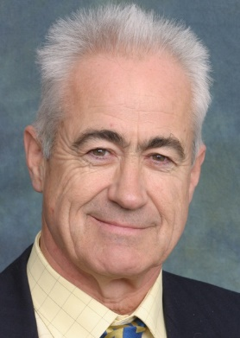
Simon John, Anti-Slavery International Fundraiser
Simon John is a fundraiser for Anti-Slavery International, he is a retired solicitor; qualified in 1969 and specialised in claims on the part of catastrophically injured people including too many children with cerebral palsy. From a small town in Norfolk he developed a team with an international practice working for people across the UK Europe and in the USA.

Simon has been a supporter of Anti-Slavery International for many years. He first rode for them in 2018, completing the London - Surrey 100 and recently spoke at the Anti-slavery International Supporter conference in November 2020. He is an almost lifelong member of Amnesty International and has held secretary and chair positions in his local Amnesty Group and has been involved in a number of cases where prisoners of conscience were released early following the application of the power of the pen. This led Simon to a deeper awareness and interest in modern slavery and two years ago he was invited to become the secretary of the global Rotary Action Group against Slavery a post that he has held since July 2019.

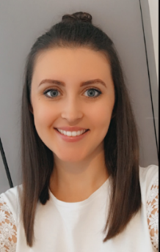
Emily Smith, Curator of Contemporary Forms of Slavery, International Slavery Museum, Liverpool
Emily Smith is the Curator of Contemporary Forms of Slavery at the International Slavery Museum. After a year working as an outreach caseworker with an NRM provider in the North West supporting survivors of slavery and trafficking, Emily began her post grad research around human trafficking, migration and organised crime. After two years of working and studying simultaneously, Emily was appointed Curator of Contemporary forms of Slavery at the International Slavery Museum. This role was created to expand the work of the museum to explore modern slavery further, in addition to its focus on the transatlantic slave trade and its legacies.

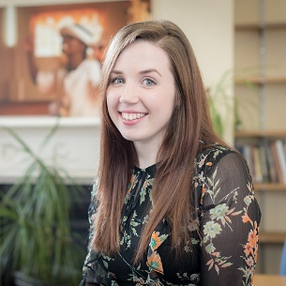
Rebecca Nelson, Wilberforce Institute, University of Hull
Rebecca Nelson is a PhD researcher and heritage professional. Her doctoral research has been funded through the AHRC’s Antislavery Usable Past project (http://antislavery.ac.uk/); a partnership between the universities of Hull and Nottingham that aimed to develop the understanding of antislavery campaigning in the past to provide lessons for the antislavery campaigns of today. Rebecca’s thesis examines the way in which museums, as arenas that showcase a ‘usable past’, engage with and interpret antislavery as both a historic and contemporary issue across the UK.
Rebecca was awarded a BA Hons. Degree in History from the University of York and an MA in Museum Studies from Newcastle University. In addition to her academic interests, Rebecca has built a successful career within the heritage sector. She is currently the Collections Development Officer for Lincolnshire Heritage Service, having previously worked as the Assistant Curator at Wilberforce House Museum in Hull. Rebecca has also held roles within Hull’s Heritage Learning team, the National Trust, the Royal Collection Trust, Beamish Museum and the International Slavery Museum. She specialises in the interpretation of, and public engagement with, challenging histories.

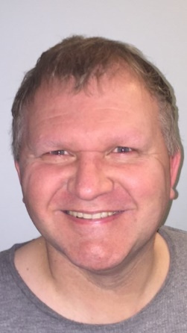
Carl Sucking, Diverse Communities Forum, Cambridgeshire County Council
Carl Suckling is currently a Youth & Community Co-ordinator and works for Cambridgeshire County Council. Carl has worked with the Wisbech community for nearly 15 years on a variety of projects and is involved in a wide range of organisations and groups including the Wisbech Community Locally Led Development Committee, I Love Wisbech Steering Group, Fenland Diverse Community Forum and the Fenland Community Safety Partnership.

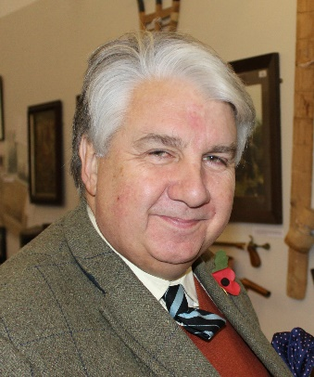
Richard Barnwell Esq D.L. Chairman of the Board of Directors of Wisbech and Fenland Museum.
Richard Barnwell, D.L. was Mayor of Wisbech in 2000 and appointed a Cambridgeshire Deputy Lieutenant in 2004. High Sheriff of the county in 2012 and Vice Lord Lieutenant 2017-2020. Richard was instrumental in the campaign to commemorate Thomas Clarkson in Westminster Abbey and this was achieved in 1996 on the 150th Anniversary of his death. Richard also worked closely with the late Brian Payne in the restoration of our Towns fine Gilbert Scott memorial to the work of Thomas Clarkson. Richard is a member of Anti Slavery International and works with several charities in Cambridgeshire to aleviate poverty and exploitation.

Sarah Coleman, Project Officer, Wisbech & Fenland Museum
Sarah Coleman is the Articles for Change Project Officer, she has held various roles in Museums since 2012 in Norfolk and Cambridgeshire and specialises in engagement, communities, volunteers, visitor experience and collections. She completed an MA in Museum Studies in 2016. Prior to working in museums Sarah worked in Local Authority on community and neighbourhood regeneration projects. Sarah’s work on Articles for Change has focused on developing new learning and engagement opportunities for young people and widening access to the museum’s collection.

